**Movimientos completos**

1. Funcionamiento

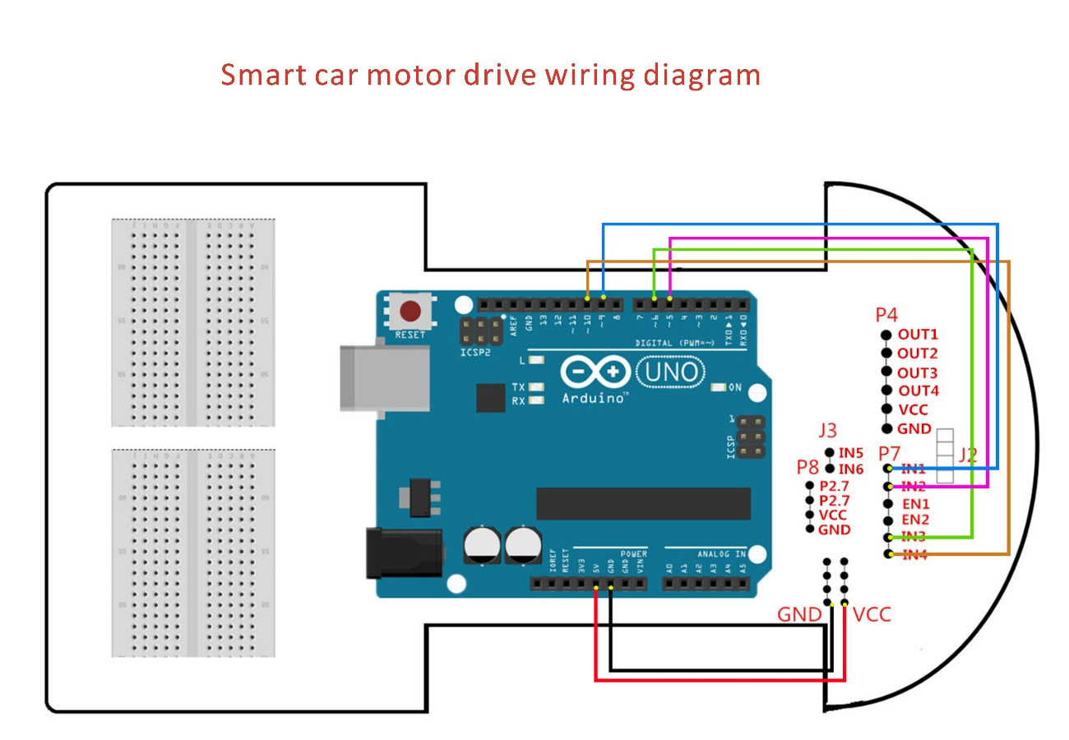

1. Código

int Left_motor_back=9; //(IN1)

int Left_motor_go=5; //(IN2)

int Right_motor_go=6; //(IN3)

int Right_motor_back=10; //(IN4)

void setup()

{

pinMode(Left_motor_go,OUTPUT);

pinMode(Left_motor_back,OUTPUT);

pinMode(Right_motor_go,OUTPUT);

pinMode(Right_motor_back,OUTPUT);

}

void run(int time)

{

digitalWrite(Right_motor_go,HIGH);

digitalWrite(Right_motor_back,LOW);

analogWrite(Right_motor_go,200);

analogWrite(Right_motor_back,0);

digitalWrite(Left_motor_go,HIGH);

digitalWrite(Left_motor_back,LOW);

analogWrite(Left_motor_go,200);

analogWrite(Left_motor_back,0);

delay(time * 100);

}

void brake(int time)

{

digitalWrite(Right_motor_go,LOW);

digitalWrite(Right_motor_back,LOW);

digitalWrite(Left_motor_go,LOW);

digitalWrite(Left_motor_back,LOW);

delay(time * 100);

}

void left(int time)

{

digitalWrite(Right_motor_go,HIGH);

digitalWrite(Right_motor_back,LOW);

analogWrite(Right_motor_go,200);

analogWrite(Right_motor_back,0);

digitalWrite(Left_motor_go,LOW);

digitalWrite(Left_motor_back,LOW);

analogWrite(Left_motor_go,0);

analogWrite(Left_motor_back,0);

delay(time * 100);

}

void spin_left(int time)

{

digitalWrite(Right_motor_go,HIGH);

digitalWrite(Right_motor_back,LOW);

analogWrite(Right_motor_go,200);

analogWrite(Right_motor_back,0);

digitalWrite(Left_motor_go,LOW);

digitalWrite(Left_motor_back,HIGH);

analogWrite(Left_motor_go,0);

analogWrite(Left_motor_back,200);

delay(time * 100);

}

void right(int time)

{

digitalWrite(Right_motor_go,LOW);

digitalWrite(Right_motor_back,LOW);

analogWrite(Right_motor_go,0);

analogWrite(Right_motor_back,0);

digitalWrite(Left_motor_go,HIGH);

digitalWrite(Left_motor_back,LOW);

analogWrite(Left_motor_go,200);

analogWrite(Left_motor_back,0);

delay(time * 100);

}

void spin_right(int time)

{

digitalWrite(Right_motor_go,LOW);

digitalWrite(Right_motor_back,HIGH);

analogWrite(Right_motor_go,0);

analogWrite(Right_motor_back,200);

digitalWrite(Left_motor_go,HIGH);

digitalWrite(Left_motor_back,LOW);

analogWrite(Left_motor_go,200);

analogWrite(Left_motor_back,0);

delay(time * 100);

}

void back(int time)

{

digitalWrite(Right_motor_go,LOW);

digitalWrite(Right_motor_back,HIGH);

analogWrite(Right_motor_go,0);

analogWrite(Right_motor_back,150);

digitalWrite(Left_motor_go,LOW);

digitalWrite(Left_motor_back,HIGH);

analogWrite(Left_motor_go,0);

analogWrite(Left_motor_back,150);

delay(time * 100);

}

void loop()

{

delay(2000);

back(10);

brake(5);

run(10);

brake(5);

left(10);

right(10);

spin_right(20);

spin_left(20);

brake(5);

}